Ideation Phase
Define the Problem Statements

Date | 5 April 2026
Team ID | SWTID-2026-5153
Project Name | Automating employee data
Maximum Marks | 2 Marks

Customer Problem Statement
Managing employee data manually is time-consuming and prone to errors. Organizations often face difficulties in maintaining employee records, tracking attendance, handling payroll, and retrieving information quickly. Manual systems also lead to data duplication, lack of security, and reduced efficiency.
Therefore, there is a need for an automated employee data management system to improve accuracy, reduce manual work, and provide quick access to employee information, ultimately increasing organizational productivity.

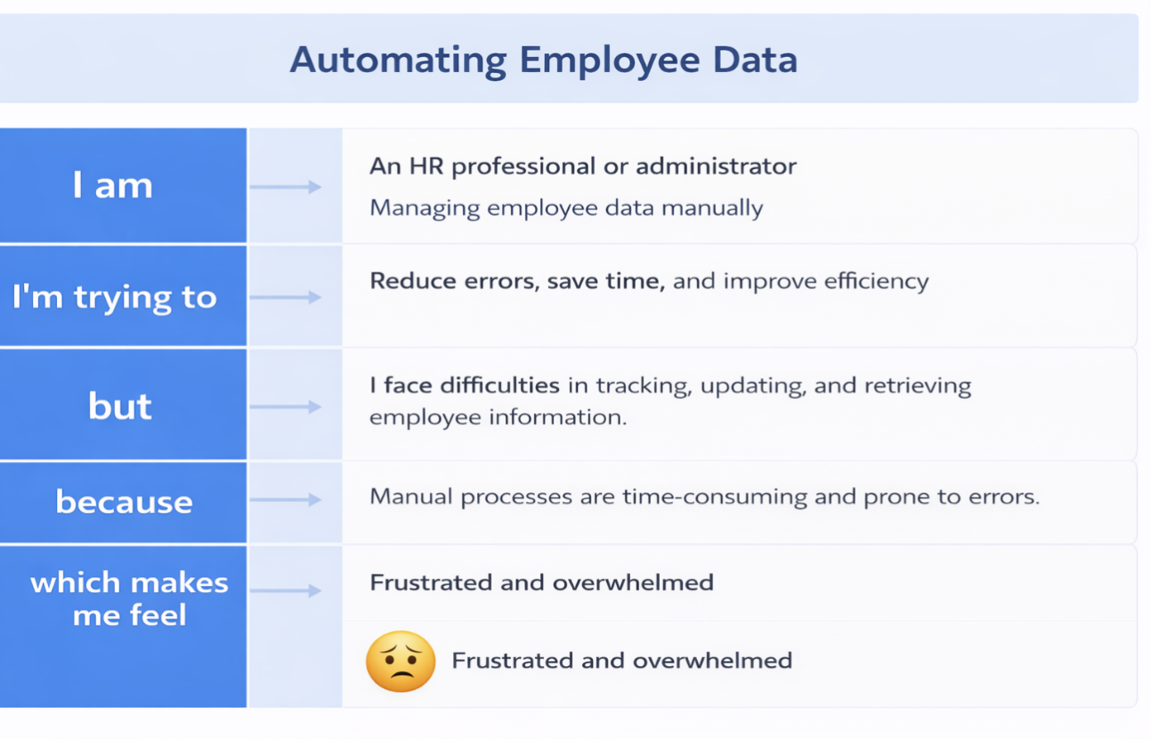

Example:
